

**For all Patients, Carers and Renal Staff**

**N E W S L E T T E R**

Winter Edition

**The Kidney Bean**

**Sponsored by the Norfolk Renal Fund**

**Dear reader,**

As the air turns crisp and frosty, we are delighted to present to you: The Kidney Bean – **Winter Edition.** This season has inspired us to curate a collection of heart-warming stories, captivating articles and exciting updates that are sure to add a touch of magic to your winter days.

So, grab your cosiest blanket, brew a cup of something warm, and let this newsletter be your companion, offering inspiration and comfort throughout this wonderful season.

Thank you for being part of this amazing community!

**Becci**

**Specialist Nurse/Editor**

Editor’s note

The Spring Edition will have a feature article on hidden talents – are you a keen artist? Musician? Do you have your own business? Let us know! Email: **norfolkkidneybean@gmail.com**

**ISSUE 2 | Winter Edition 2023 Page 1**



**Christmas Jumper Day!**

**Thursday 21st December & Friday 22nd** **December**

Upcoming Events

All proceeds will go to the Norfolk Renal Fund.

**Raffle tickets will cost £2 per strip and can be collected from the Norfolk and Norwich Kidney Centre Reception.**

Please make sure to leave your name and number so we know who to call if you win!

Winners will be announced the first week in December!

Good luck!!

**ISSUE 2 | Winter Edition 2023 Page 2**

Join in for your chance to win the following:

**A £20 One4all Gift Card (which can be used in over 170 stores or online!)**

**A luxury food hamper filled with various festive treats (displayed in NNKC reception) (worth £25!)**

Christmas Raffle (!)

We are asking everyone to come in wearing something Christmassy on these days to get us in the festive spirit – if you don’t have a Christmas jumper, feel free to get creative! T-shirts, earrings socks… what ever you may have at home.

**MEET THE TRUSTEES**

The Norfolk Renal Fund was founded in 1995.

Their aim is to provide:

* **Assistance in providing facilities/equipment not provided by the National Health Service (NHS)**
* **Help to fund training for staff**
* **To promote the understanding of renal disease to members of the public**
* **To provide support to patients and carers**

The Norfolk Renal Fund (NRF) – **Who are we?**

**Dr Mahzuz Karim**

**Consultant Nephrologist**

**Philip Norton**

**Local Solicitor**

**Mark Proctor**

**Local Accountant**

**Dr Mark Andrews**

**Consultant Nephrologist**

Please visit [www.norfolkrenalfund.com](http://www.norfolkrenalfund.com) for further information!

**John Curtis**

**Patient Representative**

**ISSUE 2 | Winter Edition 2023 Page 3**

Over the last year energy prices have soared leaving many of us struggling to make ends meet.

Your energy bills should have gone down a little as from 1st July 2023 as the Energy Regulator Ofgem has lowered its energy cap to £2,074 per year, which is £1,206 lower than previous cap so hopefully you should start to see a few savings soon.

Although this drop is only a little help, it still leads a lot of people struggling and the crisis is far from over.

So, a few energy saving tips or reminders have been asked for:

* **Heat the person:** Layer up, use hot water bottles, heated blankets or drink warm beverages to stay cosy without relying heavily on heating.
* **Use draft stoppers:** Place draft stoppers or rolled up towels along the bottom of doors to prevent cold air entering your home.
* **Program your thermostat:** Set your thermostat to a lower temperature when you’re away or sleeping and raise it when you are at home. On average, you could save around £70 per year (Citizen’s Advice).
* **Create warmth zones:** Turn the radiators off in the rooms you don’t use and focus on heating the areas where you spend most of your time.
* **Get active:** Engage in physical activity to keep your body warm and increase blood circulation (exercise is a great mood booster too!).

By adopting these energy-saving and cost-effective measures, you can stay warm during the winter season whilst keeping your utility bills under control. Remember, small changes can add up to significant savings over time.

Energy Saving Tips: **Staying warm without breaking the bank!**

**ISSUE 2 | Winter Edition 2023 Page 4**

**Visit** [**www.thepsr.co.uk**](http://www.thepsr.co.uk) **to join the register.**

**ISSUE 2 | Winter Edition 2023 Page 5**

**HAVE YOU HEARD OF THE PRIORITY SERVICES REGISTER (PSR)?**

**Peace of mind:**

You are able to set up your own password with PSR when electricity or gas employees knock at your door – protecting your personal and home security.

**Emergency gas:**

If you are on mains gas and your supply is interrupted for a prolonged period, PSR will help you with emergency electrical heating and cooking appliances.

**Emergency power:**

If you use medical equipment/aids which use electricity or water, the PSR helps to prioritise help during prolonged supply interruptions.

**Communication tailored to your needs:**

You can request a format that suits your needs e.g., large print, Braille, textphone, audio or another language.

**Connection to local emergency services:**

The electricity/gas companies work with local authorities, emergency services and agencies like the British Red Cross, to provide extra support.

**Support and information during a power/gas supply interruption:**

24-hour access to network operators in the UK all day, every day. You will get priority updates and you will get prior advance notice to allow you to plan ahead.

The PSR is a **FREE** UK wide service which provides extra advice and support, including when there’s an interruption to your **electricity, gas or water supply.**

You are eligible for this service if you:

* Use medical equipment reliant on electricity or water
* Are deaf or hard of hearing
* Have a disability
* Have a chronic illness
* Are of a pensionable age
* Are blind or partially sighted
* Have anxiety, depression or any mental health condition
* Live with children under five
* Need documents translated into another format or language

**INTENDED BENEFITS:**

Welfare: **Priority Services Register (PSR)**

**ISSUE 2 | Winter Edition 2023 Page 6**

If you feel you need **professional mental health support**, please contact Kidney Care UK counselling and support service on **01420 541424**.

1. **Avoid isolation:** Stay socially engaged; participate in activities you enjoy, spend time with loved ones and maintain social connections – why don’t you organise a social event with your fellow peers?
2. **Nutrition and Diet:** Proper nutrition can positively impact your health, and in turn influence your emotional wellbeing.

Please speak to one of our Renal Dieticians if you want further advice and support with this.

1. **Physical activity:** Engaging in physical activity can improve your mood and overall wellbeing. Even light exercise such as walking can have a positive impact on mental health. Get family and friends involved too! (Watch out for the Step Count Challenge in the next edition!)
2. **Build a support network:** connect with friends, family or your peers also on dialysis. Sharing experiences and feelings with others who are going through similar situations can be very comforting.
3. **Education and information:** Educate yourself about your condition, the symptoms, the varying treatment options - are you on haemodialysis? Is home haemodialysis an option for you? Or peritoneal dialysis? Knowing more will empower you and enable you to make more informed decisions about your care.

Health & Lifestyle: **Mental Health Awareness**

**ISSUE 2 | Winter Edition 2023 Page 1**

Living with a chronic kidney condition can be challenging, both physically and mentally. The winter season can impact mental health in various ways such as vitamin D deficiency, isolation, financial stress due to increased heating bills and lack of exercise in the cold weather.

Here are some strategies to support your mental wellbeing:

**Are you looking for some winter sun? Or planning a holiday for next year?**

Freedom: The Holiday Specialists are the UK’s first and only travel company that specialises in arranging holiday dialysis for kidney patients. The trained travel consultants you will speak to have over 45 years’ experience between them and understand that every dialysis patient has very different needs, which is why every holiday is tailor made to suit you!

Feature Article: **FREEDOM - The Dialysis Holiday Specialists**

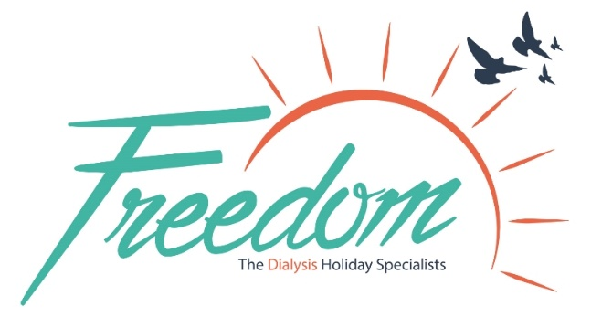

**ISSUE 2 | Winter Edition 2023 Page 7**

Greece? Spain? Switzerland? Or somewhere further afield like Singapore? With over 400 dialysis centres in over 60 destinations, Freedom has something to suit everyone. Freedom will take care of liaising with both overseas and base dialysis units to seamlessly coordinate your holiday requirements. Their fee for organising this is £80 for within Europe, whereas Worldwide or USA is £100. This is a one-off charge that covers the cost of administration and assistance throughout the process.

To book or for more information, contact Freedom by:

**Telephone:** 01509 815999

**Email:** [info@holidaydialysis.co.uk](mailto:info@holidaydialysis.co.uk)

**Website:** www.holidaydialysis.co.uk

**EHIC/GHIC INFORMATION**

**Dialysis is FREE within EU countries, using either an in-date European Health Insurance Card (EHIC) or the new Global Health Insurance Card (GHIC). However, not every unit will accept this as a form of payment.**

EU countries are: Austria, Belgium, Bulgaria, Croatia, Republic of Cyprus, Czech Republic, Denmark, Estonia, Finland, France, Germany, Greece, Hungary, Ireland, Italy, Latvia, Lithuania, Luxembourg, Malta, Netherlands, Poland, Portugal, Romania, Slovakia, Slovenia, Spain and Sweden.

**Some countries may ask for a small supplement in addition to the EHIC/GHIC like Switzerland, we will provide this information with any requests made via our services.** If you travel to a country which does not accept the EHIC/GHIC, you may have to pay the full costs of your haemodialysis treatment while you are away. **Please note that EHIC and GHIC cards are not a replacement for comprehensive travel insurance.**

Before travelling, it is very important that you apply and receive confirmation from your chosen healthcare provider that your treatment will be covered on your EHIC/GHIC.

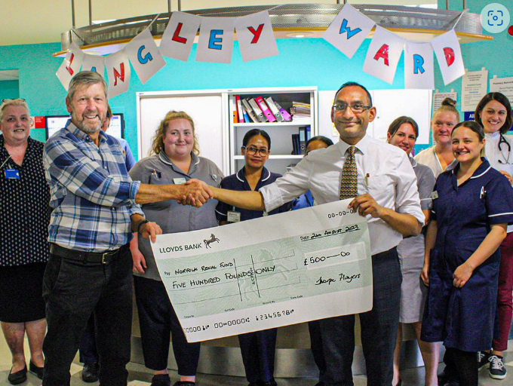

Do you have a passion for amateur dramatics?

Or want to try something new?

Thorpe Players latest productions and group details can be found here: [www.thorpe-players.co.uk](http://www.thorpe-players.co.uk) and they are always happy to receive new members.

**Thorpe Players, a local amateur dramatics group, recently ran a charity concert night to raise money for local charities (Boudicca Breast Cancer and the Norfolk Renal Fund).**

**They were successful in raising £1,000, which was split evenly between the two charities.**

Thorpe Players is a community-based theatre group that has been in residence at Roxley Hall, Thorpe St. Andrew for over 50 years. Dave, who has haemodialysis three times a week at Bowthorpe, Norwich, was approached by the leaders of Thorpe Players to see if he would like to get involved in this event. He has kindly shared his story:

“One of my passions since primary school was performing on stage mainly in school productions, but also some television work. I have worked on shows such as Byker Grove, Catherine Cookson films and more recently Stephen Fry’s Norfolk detective programme called Kingdom.

Having been diagnosed with chronic kidney disease (CKD), my biggest concern was whether or not I would be able to carry on doing drama to the extent I was. I had a real fear that this CKD would rob me of something I love doing through tiredness and exhaustion. Fortunately for me, the dialysis treatment has allowed me to get back to doing drama, performing in several plays since starting treatment. I am now looking forward to performing in another musical in February 2024 and making my directing debut for an Agatha Christie play.

In February this year, I was approached by the leaders of Thorpe Players to see if I would consider being part of a charity concert. The aim would be to run a night of “Music from the Movies”, for one night only, with the purpose of raising money for local charities. In the group we have had several members battling with CKD as well as members also suffering from breast cancer. Therefore, the decision was made to raise money and split the profits between Norfolk Renal Fund and The Boudica Breast Cancer unit and NNUH.

So, on Friday July 28th we sang a wide range of song from Movies to a full house. It was a privilege for me to sing solo songs from Dear Evan Hansen and Les Misérables. We finished the evening with audience participation singing along to all the favourites from the Sound of Music. It was such fun night enjoyed by everyone.”

*Cast of Music from The Movies from Thorpe Players.*

‘Music from the Movies’ – **One Night Only!**

**ISSUE 2 | Winter Edition 2023 Page 8**

*Dave Watson, Thorpe Players Chairman, presenting the cheque to the Norfolk Renal Fund at NNUH.*

**ISSUE 2 | Winter Edition 2023 Page 9**

Are you thinking about competing? The 2024 British Transplant Games will take place in Nottingham, dates to be confirmed. **Registration for this event is expected to be around February 2024.**

Please visit [www.britishtransplantgames.co.uk](http://www.britishtransplantgames.co.uk) for more information.

*Have you competed in the British Transplant Games? Or know someone who has? Write in and let us know – we would love to share your story! - norfolkkidneybean@gmail.com*

What are the British Transplant Games you ask? **A celebration of life**. This event takes place every summer, hosted by different cities across the UK. Coventry have just hosted the British Transplant Games in July this year– 4 days of games, 1000+ transplant recipients taking part, 25+ sporting events and 1500+ supporters watching the games.

Transplant recipients as young as five years old can compete in more than 25 sports, and many athletes can go on to compete in the World Transplant Games.

The aim of this event is to encourage transplant recipients to lead active lifestyles, to show appreciation for donors and their families and raise awareness of the need for organ donation.

Feature Article: **British Transplant Games 2023**

*Images taken from* [*www.britishtransplantgames.com*](http://www.britishtransplantgames.com)

Patient Story: **The comeback is always stronger than the setback**

**ISSUE 2 | Winter Edition 2023 Page 10**

***Written by Gillian Mellor***

“I am quite new to haemodialysis, having started dialysis in March this year. Prior to this, I had 2 years on peritoneal dialysis before a successful kidney transplant in 2014. My husband and I were part of the Living Kidney Sharing scheme with two other couples. In January it was discovered I had cancerous tumours in my transplant and although my kidney was working well, unfortunately it had to be removed. Thankfully it appears the cancer was contained, and I’m now having regular scans and check-ups.

The first few months on dialysis have been a challenge, but as I’ve regained my strength and confidence, I realise I can do lots of the same things I did before, for example, Zumba and Pilates! Albeit not at the same level, but I can still join my friends!

I think the turning point for me was going on holiday earlier this month. We visited our brand-new grandson in Brighton. I booked ‘holiday dialysis’ through Kidney Care UK: Dialysis Freedom. Together with help from the nurses here, tests were co-ordinated, and everything went smoothly. The staff at the unit in Brighton were very welcoming and I would certainly go away again.

I have also been asked to choose a charity for our Zumba ball this year, so we are hoping to raise some money for a local kidney charity.   
  
I have found dialysing with other people a great help, sharing tips and recipes regarding food and fluid restrictions is invaluable!”



**Ingredients:**

**1 tablespoon olive oil**

**1 leek, cut into chunks**

**1 clove garlic, crushed**

**1 onion, chopped**

**2 carrots, cut into chunks**

**1 large parsnip, cut into chunks**

**2 tablespoons of flour**

**400ml low-salt vegetable stock**

**400g can of beans (butter/cannellini beans or chickpeas can be used)**

**1 tablespoon fresh rosemary, chopped**

**200ml crème fraiche**

**150g frozen peas**

**Cheddar Dumplings**

**80g self raising flour**

**30g vegetarian suet**

**60g cheddar cheese, grated**

***If you are not vegetarian, why not add some braised beef?***

Winter recipes: **Main Meal**

VEGETABLE STEW WITH CHEDDAR DUMPLINGS

**Prep time: 20 minutes Cook time: 90 minutes Serves: 4**

Winter recipes | **Main Meals**

* **Low Phosphate**
* **Low Potassium**
* **Low Salt**

**ISSUE 2 | Winter Edition 2023 Page 11**

**METHOD:**

1. Heat the olive oil in a large, lidded pan and add the leek, garlic and onion. Cook until softened.
2. Add the carrots and parsnip to the pan and cook for a further five minutes. Pour in the flour and mix it into the vegetables. Add the stock, stirring well until the flour has dissolved and there are no lumps, then add the drained beans.
3. Sprinkle over the chopped rosemary and top-up the liquid with water to ensure all of the vegetables are covered. Put a lid on the pan and simmer over a medium heat for 40 minutes.
4. While the stew is cooking, prepare the dumplings. Put the flour into a bowl and mix in the suet, cheddar and mustard. Add 2-3 tablespoons of cold water and, using your hands, combine to form a sticky dough. Divide into four and roll into balls.
5. Take the lid off the stew and mix in the peas and crème fraiche.
6. Place the dumplings on top of the stew, replace the lid and cook for a further 25 minutes.

Winter recipes: **Desserts**

**Ingredients:**

**250g pineapple pieces in juice**

**100g demerara sugar**

**50g glace cherries**

**175g self-raising flour**

**1 unwaxed lemon**

**100g unsalted butter**

**2 eggs**

**50g sultanas**

**2-3 teaspoons mixed spice**

**Extra butter for greasing**

STEAMED CHRISTMAS PUDDING

**Prep time: 90 minutes Cook time: 90 minutes Serves: 8**



**ISSUE 2 | Winter Edition 2023 Page 12**

* **Low fat**
* **Low Potassium**
* **Low Salt**

**METHOD:**

1. Butter an 850ml pudding basin and put into the fridge to set for 30 minutes. Butter the bowl again and put back into the fridge to set again for another 30minutes. Cut a small disc of greaseproof paper to fit into the bottom of the bowl.
2. Drain the pineapple through a sieve and discard the juice. Roughly chop both the pineapple and cherries into small pieces.
3. Cream the butter and sugar together until light and fluffy. Beat in the eggs a small amount at a time. Fold in the cherries, pineapple, sultanas and grate in the rind of the lemon.
4. Sift the flour and gently fold it in to the mixture with the mixed spice.
5. Transfer into the pudding basin and cover with a piece of buttered foil with a centre pleat to allow for expansion. Secure with a piece of string with a large loop for a handle.
6. Place the pudding into a steamer or use a large saucepan with a saucer in the bottom and ensure the water is halfway up the side of the bowl. Steam for 1 ½ hours until firm. Cut the string around the bowl, turn out and serve or follow storage instructions.

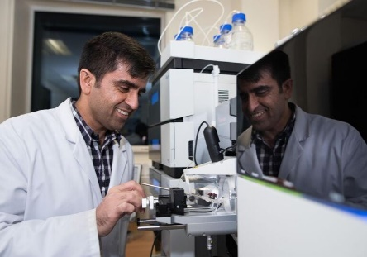

Visit [www.kidneyresearchuk.org](http://www.kidneyresearchuk.org) for more research stories!

**Redefining haemodialysis: working towards a wearable artificial kidney.**

Professor Grazia de Angelis from the University of Edinburgh has been awarded £180,000 to work on new materials to support the development of a wearable artificial kidney.

**The problem:**

Home dialysis offers some advantages over in-centre haemodialysis, but it can be a time-consuming process and the equipment is bulky so patients who dialyse at home must have sufficient storage space – this can prevent people from opting for this.

**The solution:**

Grazia and her team aim to develop a portable artificial kidney/compact dialysis machine. They aim to use artificial intelligence (AI) to speed up development and hopefully lead to cost savings.

**What does this mean for kidney patients?**

Smaller dialysis machines would help more patients access home treatment and new filter materials could enable night-time dialysis sessions, which means improved quality of life, a less restrictive dialysis schedules and hopefully offer safer and more tolerable treatment.

**Does the environment inside a kidney transplant recipient’s body play a role in transplant success?**

Dr Sadr Shaheed from the University of Oxford has just been awarded a grant of £31,000 to investigate this.

**The problem:**

The best treatment for kidney failure in most cases is a kidney transplant. However, there is a shortage of available donor organs which means people are left waiting for years before receiving a kidney. This means that those kidney transplants that do go ahead are given the best possible chance of success.

**The solution:**

Sadr and his team will analyse blood samples taken from pairs of patients who each received a kidney from the same donor but have experienced different transplant outcomes.

**What does this mean for kidney patients?**

These tests will reveal whether the environment inside the patient who is receiving a new kidney affects the chances of transplant success. The hope is to help doctors to better match donor organs with recipients and to identify targets for treatments that could prepare patients before transplant, increasing the chances of more successful transplants.

**ISSUE 2 | Winter Edition 2023 Page 13**

Research Updates: **Kidney Research UK**