**Sponsored by the Norfolk Renal Fund**

**For all Patients, Carers and Renal Staff**

Summer Edition

**N E W S L E T T E R**

**The Kidney Bean**

**ISSUE 1 | Summer Edition 2023 Page 1**

If you would like to share your story, give feedback or anything else in between for the next edition of the newsletter, please email **norfolkkidneybean@gmail.com**

**Dear reader,**

Hello! And welcome to our BRAND-NEW patient newsletter, **The Kidney Bean**! We are dedicated to providing you with valuable insights, up to date kidney research and inspiring stories to support you on your journey to optimal kidney health.

Here are some of the things in store for you (the themes will be the same, but the information will differ):

1. **Feature Article**
2. **Patient Stories**
3. **Lifestyle Tips (including new recipes every edition)**
4. **Upcoming social events**
5. **News & Updates**

We hope that these newsletters prove to be a valuable resource for you. Remember to consult with your kidney doctor/nurse for personalised advice and guidance regarding your kidney health.

Wishing you a happy and healthy summer!

**Becci**

**Specialist Nurse/Editor**

Editor’s note

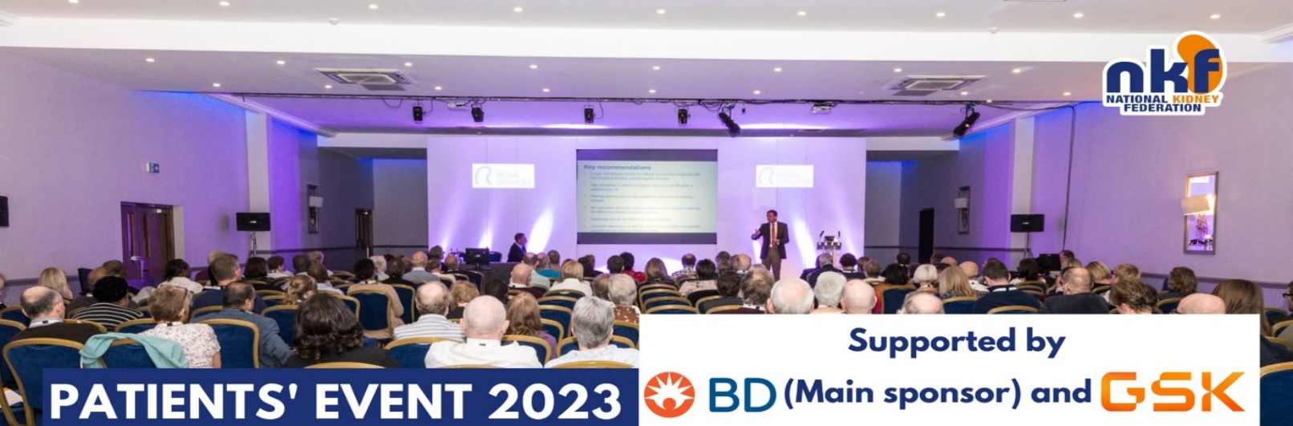

Please reach out to the Norfolk Renal Fund if you would like to attend this event but need help with funding.

**ISSUE 1 | Summer Edition 2023 Page 2**

**The National Kidney Federation (NKF) are so excited to announce that they will be holding this year’s annual patients’ event face-to-face, which also marks their 45th Anniversary! Join them at the Radisson Blu Hotel, East Midlands Airport, from Friday the 22nd – Saturday 23rd September 2023.**   
  
NKF kick the weekend off on Friday with an informal buffet supper, get to together and a quiz. The main event then takes place on the Saturday with various speakers covering subjects on paediatric care; polycystic kidney disease (PKD); chronic kidney disease (CKD) and diabetes; benefits and regional kidney networks. You will have the opportunity to ask the speakers questions. During the breaks, why not visit the exhibition hall and see our industry partners displaying their products and services and chat with fellow delegates. On the Saturday evening, socialise with old and new friends at our evening dinner. This year there is a table magician to wow you with his amazing tricks. After dinner, come join everyone on the dance floor with music till midnight.

NKF only hold this event once a year and it’s a great opportunity to attend. They anticipate this being a successful year with many asking for the return of this face-to-face event. Book your places early.

To book your place early and to view prices please visit the website: **www.kidney.org.uk/Event/national-kidney-federation-annual-patients-event-2023** or call the NKF office on **01909 544999** to reserve your place.

NATIONAL KIDNEY FEDERATION ANNUAL PATIENTS’ EVENT 2023 - BOOK YOUR PLACE NOW!

Upcoming Social Events



WALK FOR POLYCYSTIC KIDNEY DISEASE (PKD)

1ST SEPTEMBER – 30TH SEPTEMBER 2023

Fundraising Opportunities

**ISSUE 1 | Summer Edition 2023 Page 3**

The 3rd – 10th September 2023 is PKD Awareness Week, a week dedicated to educating and inspiring our friends, families and communities to learn about the condition that around 70,000 people in the UK live with. This September, join them in helping to raise awareness of PKD by organising your own sponsored walk and fundraising for PKD Charity. By fundraising for them you will be helping to fund research into a cure for PKD.

**Walk for PKD**

You choose your distance and location. you could organise a walk in the hills with friends, a marathon trek along the coast with your dog, or arrange a walk and get together with your local PKD community group. However, and wherever you choose to walk, you will be raising awareness and funds to support people affected by PKD and research in to finding a cure.

**How to get involved**

1. Register your Walk for PKD by completing the short form found at: **https://pkdcharity.org.uk/fundraising**

2. Choose a location and plan your walk

[3. Se](http://justgiving.com/campaign/WalkforPKD)[t up your fundraising page](https://www.justgiving.com/campaign/walk-for-pkd)

4. Share with your friends, family and colleagues. Get them to sign up to join you!

5. Lace up and Walk for PKD.

**Sign up to Walk for PKD and you will get:**

A fundraising guide to with lots of tips and advice

PKD t-shirts or neck buffs for you and your team

PKD Charity resources to help you promote your walk and fundraising

**More information**

If you have any questions at all or would like to have a chat about organising your own Walk for PKD then please get in touch, email [fundraise@pkdcharity.org.uk](mailto:fundraise@pkdcharity.org.uk) or call 07715 664687.

**ISSUE 1 | Summer Edition 2023 Page 11**

Benefit Entitlement – Are you eligible?

**ISSUE 1 | Summer Edition 2023 Page 4**

Living with chronic kidney disease can affect your finances and income on top of the cost-of-living crisis so many people are finding it difficult to make ends meet.

With that in mind it may be worth checking your benefit entitlement.

There are several ways to do this. Please note this list is by no means exhaustive with lots of organisations offering support and if you have received help from an organisation lets us know and we can include their details in future newsletters.

1. Visit the Kidney Care website and use their free Benefits Calculator which is free to use takes about 10-15 minutes to complete. It is anonymous and will help you identify any benefits you can claim. You can find it at [www.kidneycareuk.entitledto.co.uk/home/start](http://www.kidneycareuk.entitledto.co.uk/home/start).
2. The National Kidney Federation have produced a Benefits Guide for Kidney Patients which is a package of information you can request via their Helpline on 0800 169 0936 or by emailing [helpline@kidney.org.uk](mailto:helpline@kidney.org.uk) The pack will be sent to you and includes lots of useful information.
3. Age UK Norfolk also offers a Welfare Benefits Service for over 50. They are able to provide information and advice on benefit entitlement and how to claim. They undertake checks over the telephone but can offer a home visit for those who require them.

Telephone 0300 500 1217, Email [advice@ageuknorfolk.org.uk](mailto:advice@ageuknorfolk.org.uk) or visit website [www.ageuk.org.uk/norfolk](http://www.ageuk.org.uk/norfolk).

1. It is also worth having a look at the Department for work and pensions section of the Gov.uk website.

Just a reminder those who are eligible should receive the disability cost of living payment of £150 in July. The payment is being made to anyone who receives:

* Disability Living Allowance (DLA)
* Personal Independence Allowance (PIP)
* Attendance Allowance (AA)
* Armed Forces Independence Allowance
* Constant attendance Allowance
* War Pension mobility supplement

This payment should be made automatically - there is no need to apply, but just check your account.

**More information is available on the Gov.uk website –** [**www.gov.uk/cost-of-living**](http://www.gov.uk/cost-of-living)**.**

**ISSUE 1 | Summer Edition 2023 Page 5**

I know most of us look forward to summer – the long evenings and warmer weather. However, when you have kidney disease and/or on dialysis, drinking more is not always the best option to keep cool. Here are some handy tips and tricks to help you stay cool during the summer season:

* Try freezing berries or grapes for a cold, refreshing snack.
* Sip your beverages slowly. Sipping will let you savour the liquid longer.
* Use small cups or glasses for your beverages.
* Freeze your water in an ice cube tray.
* Wet and freeze washcloths to put on your neck to keep you cool.
* Place a bowl of ice in front of a fan to help cool the air.
* Go somewhere with air conditioning - e.g. a restaurant, shopping centre, community centre or cinema.
* To help control your thirst, limit the amount of salty foods you eat.
* Try drinking cold liquids instead of hot ones.
* Snack on low-potassium vegetables and fruits that are ice cold, like chilled sliced pears, apples, grapes or strawberries.
* Wear a hat when you have to go out in the sun.
* Wear loose and light cotton clothing.

**IF YOU ARE TRANSPLANTED**

The anti-rejection drugs you take to prevent your body from rejecting your kidney transplant do so by suppressing your immune system. Your immune system is designed to fight infection, but it also detects and destroys cells that can become cancerous. This means that your medications can increase the chances of getting some sorts of cancers, including skin cancer, so it is very important to always wear high factor protection suncream.

Health & Lifestyle: **Tips on how to stay cool in the heat weather**

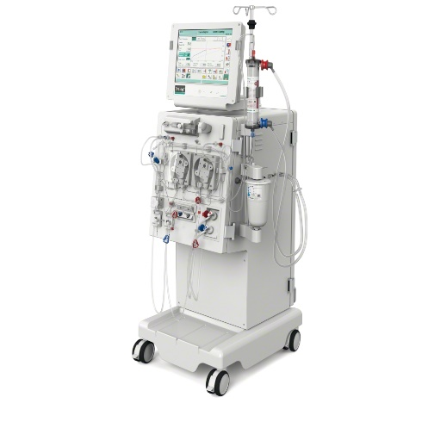

**‘Exit Site’** – the area where the peritoneal catheter exits the skin.

**‘Exchange’** – the process of draining out old dialysate fluid and putting fresh fluid in. This normally take around 30 minutes to complete.

**‘Dwell Time’** – the length of time the dialysate fluid stays in the peritoneal cavity.

**‘Bruit’** – the sound produced by the blood flowing through the blood vessel (e.g. fistula).

**‘Thrill’** – a vibration or buzzing that you should be able to feel when touching a fistula (due to high blood flow in the blood vessel).

**‘Blood Pump’** – a pump that helps to move your blood from your fistula/neckline through the dialyser and back to you without causing damage to the blood cells.

**‘Dialysate’** – a solution of water and electrolytes that passes through the dialyser, to help remove excess fluid and waste products from the blood.

**‘Dialyser’** or **‘Artificial Kidney’** – this is a filtering device that is used to remove excess fluid and waste products from your blood.

**ISSUE 1 | Summer Edition 2023 Page 6**

When you start dialysis, you will start hearing new terms such as **‘dry weight’**, **‘dialyser’** or **‘exchange’**. As the patient, this brand-new process can be very scary and confusing. This article aims to translate some of the medical jargon that you may hear in the dialysis unit.

Feature Article: **DIALYSIS LINGO - TRANSLATED**

**PERITONEAL DIALYSIS**

**‘Peritoneum’** – a natural membrane that lines the wall of the abdomen and provides the dialysis membrane for peritoneal dialysis. It has a large surface, contains many holes and has a rich blood supply.

**HAEMODIALYSIS**

**ISSUE 1 | Summer Edition 2023 Page 7**

**‘Adequacy’ –** a term that refers to how well dialysis is working. Certain tests are carried out to see if enough fluid and toxins are being removed from the blood.

**‘Erythropoietin (EPO)’** - a hormone produced by the kidneys that encourages your body to make red blood cells. Without this, people can become anaemic. We can give this hormone through the dialysis machine/into your tummy (called Aranesp/Eprex).

**‘Anaemia’** – a condition where a person has a low number of red blood cells or haemoglobin in their blood, resulting in tiredness and being pale in colour.

**‘Toxins/Waste products’** – substances that are formed from the breakdown of protein in foods and from normal muscle activity. The kidney usually filters the blood, and the toxins/waste products are removed in the urine.

**‘Fluid Overload’ –** when extra fluid in the body causes symptoms such as breathlessness, swelling and/or extra strain on the heart.

**‘Chronic Kidney Disease’ –** permanent loss of kidney function, worsening over several months or years.

**‘Anuric’** – a term used to describe someone who does not pass any urine (this is very common in those who have haemodialysis).

**‘Anticoagulant/blood thinner’** - medication that stops the blood from clotting.

**‘Dry Weight’** - your weight once all the extra fluid has been removed.

**GENERAL TERMS**

Feature Article: **DIALYSIS LINGO - TRANSLATED**

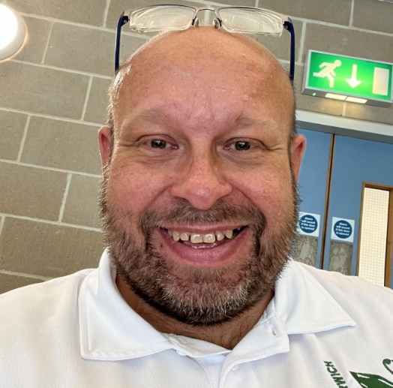

**My name is Dave Montgomery, I am 48 years old, and I am currently having haemodialysis in Bowthorpe on a Tuesday, Thursday and Saturday morning.**

I am happily married to Emma with three children – Max (20), Amber (17) and Zach (13). I am originally from Newcastle but have lived in East Anglia working for BT for 26 years. I continue to work from home whilst doing dialysis during the week and my work are extremely supportive.

In 2021, having delayed a trip to New York with my dad, I rebooked this trip for July 2022. However, it was in February 2022 that my consultant decided that I wasn’t well and needed to start dialysis which then threw the whole trip into question.

Some of my main concerns were around organising dialysis, insurance and about health in general. In the end we decided we would try and go for it.

Patient Story: Norwich 🡪 New York

**ISSUE 1 | Summer Edition 2023 Page 8**

My first point of contact was to talk to my insurance. Luckily, they advised me that because I had booked this trip before knowing I would start dialysis, they would cover my existing booking.

I felt it would be easier to organise my dialysis through a company who specialise in organising dialysis treatment across the world (Freedom: The Dialysis Holiday Specialists). However, this still proved to be more difficult than I first thought. In the United States (US), specifically Manhattan, no one was taking on dialysis patients because of COVID and we immediately hit a brick wall. However, after some chasing, we found a unit that was taking patients, but this was at a cost of $600 per session. I needed two sessions and fortunately my dad agreed to pay the fee for me.

The process of getting there was tense, and I think this was more to do with the requirements of the centre in the US more than you might get from anywhere else, say in Europe. The centre in the US required (and still do) a heart scan, a chest scan, blood tests and a COVID PCR test. Thankfully, the team at Bowthorpe helped me get all of this. They gave all the information to Freedom who then liaised with the US Centre.

I chose to attend a 5:30am chair session whilst visiting New York. I did this because I wanted to maximise my day. My impression of US hospitals was limited to what you might see on US hospital dramas, but in reality, it wasn’t as nice as you might imagine. Functional – yes, but that’s all it was. And there was no tea and biscuits – and that’s the best part of dialysis! However, the staff were friendly and warm, and it wasn’t unpleasant, but this was a last resort choice, and I am sure there are nicer places in New York to be treated.

Now that I have been and know what to expect, I would go again. The first challenge really is insurance. For the trip in 2022 I didn’t have to have specialist insurance, but that is not the case now. Insurance cost for the week is huge and can be the same price as the flight. Plus, the cost of dialysis whilst there. New York isn’t covered by the GHIC/ EHIC card so you are effectively having to pay for private hospital treatment. And having enquired again for this year, the requirements of PCR, chest X-ray etc. is still required, and that again is something that needs planning for. I don’t believe there is such strict requirements on travel to other European destinations, some of which do cover your treatment.

Finally – did I have a good time? Yes. It was fantastic to do such a major trip whilst living with chronic kidney disease.

Was it a hassle to get there? Yes.

**Was it worth it? For sure!**

**ISSUE 1 | Summer Edition 2023 Page 8**

**Ingredients:**

**400g penne pasta, dried**

**1 tablespoon olive oil**

**2 garlic gloves, thinly slices**

**400g fresh tomatoes (roughly chopped)**

**50g pitted black olives (roughly chopped)**

**1 onion, thinly sliced**

**1 courgette, cubed**

**½ teaspoon chilli flakes (optional)**

**340g tinned tuna in spring water**

**Ground black pepper**

**10g basil leaves**

TUNA, TOMATO AND OLIVE PASTA

**Prep time: 10 minutes Cook time: 15 minutes Serves: 4**

Summer recipes: **Main Meals**

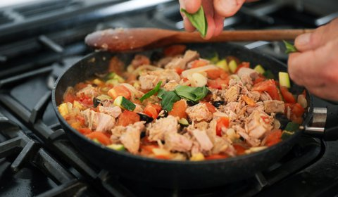

**ISSUE 1 | Summer Edition 2023 Page 9**

**METHOD:**

1. Fill a large saucepan with water and bring to the boil. Once boiling, add the pasta and cook for 10-12 minutes, or as per instructions on the packet.
2. Add the oil to a frying pan and place over a medium heat. Add the garlic, tomatoes, olives, onion and courgette cubes to make your sauce.
3. Stir in the chilli flakes and bring the sauce to the boil, then reduce the heat and simmer for five minutes. Stir in the chilli flakes and bring the sauce to the boil, then reduce the heat and simmer for five minutes.
4. Open and drain the tin of tuna. Break the tuna up with a fork and stir into the sauce. Simmer for two minutes.
5. Season with black pepper. Gently tear the basil leaves and add them to the sauce.
6. When cooked, drain the pasta and carefully toss through the sauce. To serve, divide between four plates.

* **Low Phosphate**
* **Low Potassium**
* **Low Salt**

**£1.58 per portion!**



ETON MESS

**Prep time: 10 minutes Cook time: 7 minutes Serves: 6**

Summer recipes: **Desserts**

**METHOD:**

1. For the coulis, tip all of the ingredients into a saucepan and heat for 5-7 mins. Blend in a food processor until smooth, then pass through a sieve to remove the pips. Set aside until ready to serve.
2. Break up the meringues into pieces and set aside. Lightly whip the cream until soft peaks form. Be careful not to over whip it. Gently fold in the raspberries, blueberries, and meringue pieces.
3. Add the vanilla extract. Stir through some of the raspberry coulis. You want a ripple effect with the raspberry running through it.
4. Serve drizzled with the raspberry coulis. For an extra flourish, crumble the ginger biscuits over the top.

* **Low Phosphate**
* **Low Potassium**
* **Low Salt**
* **Low protein**
* **Low fat**

**£1.26 per portion!**

**Ingredients:**

**4 individual meringue nests (shop bought)**

**400ml double cream**

**1 teaspoon vanilla extract**

**150g fresh raspberries**

**150g fresh blueberries**

**2-4 ginger nuts (optional)**

**Raspberry coulis:**

**200g frozen raspberries**

**30g caster sugar\***

**1 tablespoon lemon juice**

*diabetic patients can choose sugar free option

**Visit** [**www.kidneycareuk.org**](http://www.kidneycareuk.org) **for more recipes!**

**ISSUE 1 | Summer Edition 2023 Page 10**

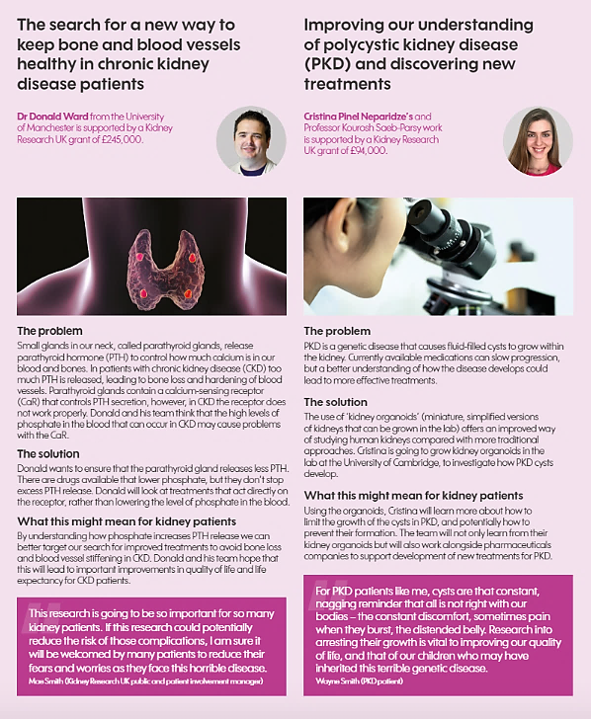

[www.kidneyresearchuk.org/sign-up-update/magazine](http://www.kidneyresearchuk.org/sign-up-update/magazine)

**ISSUE 1 | Summer Edition 2023 Page 11**

Research Updates: **Kidney Research UK**

[](https://www.google.com/url?sa=i&url=https://www.nephrocare.co.uk/about-us/news/news/national-kidney-federation-supports-home-dialysis-for-lower-covid-19-risk.html&psig=AOvVaw2f7YiQSiPR4GKZ_gE_K8SL&ust=1628578023587000&source=images&cd=vfe&ved=0CAcQjRxqFwoTCKijjYeso_ICFQAAAAAdAAAAABAD)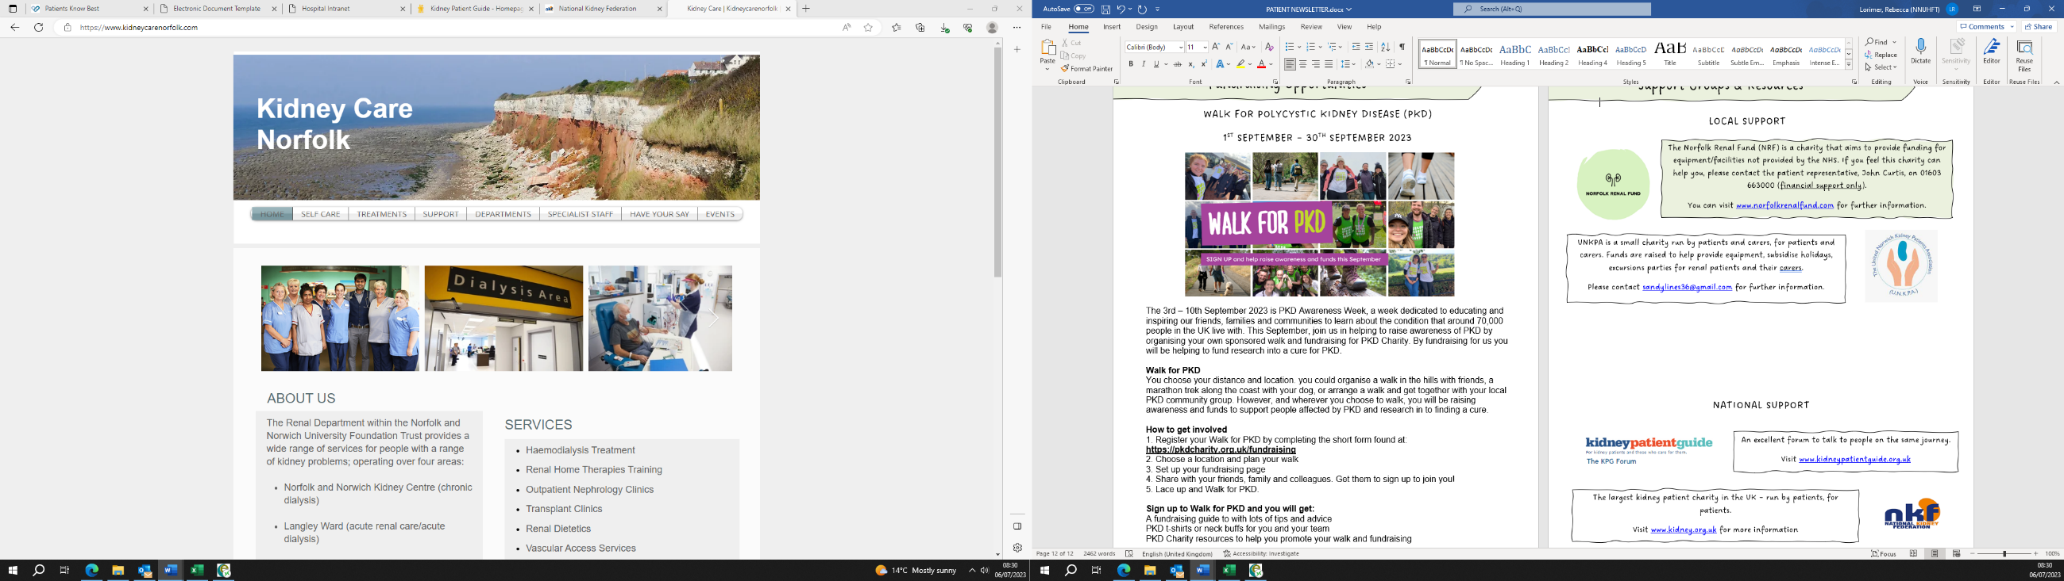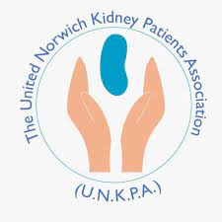

**ISSUE 1 | Summer Edition 2023 Page 12**

A wealth of information about different kidney conditions and reports on recent research.

Visit [www.kidneyresearchuk.org](http://www.kidneyresearchuk.org)

The largest kidney patient charity in the UK – run by patients, for patients.

Visit [www.kidney.org.uk](http://www.kidney.org.uk) for more information

An excellent forum to talk to people on the same journey.

Visit [www.kidneypatientguide.org.uk](http://www.kidneypatientguide.org.uk)

**NATIONAL SUPPORT**

Website specific to Kidney Care in Norfolk – Visit [www.kidneycarenorfolk.com](http://www.kidneycarenorfolk.com) to find tips on how to self-care, diet sheets, pictures/videos of how dialysis works, contact details of specialist team members and much more.

UNKPA is a small charity run by patients and carers, for patients and carers. Funds are raised to help provide equipment, subsidise holidays, excursions parties for renal patients and their carers.

Please contact [sandylines36@gmail.com](mailto:sandylines36@gmail.com) for further information.

The Norfolk Renal Fund (NRF) is a charity that aims to provide funding for equipment/facilities not provided by the NHS.

You can visit [www.norfolkrenalfund.com](http://www.norfolkrenalfund.com) for further information.

**LOCAL SUPPORT**

Support Groups & Resources